# CS 255 System Design Document Template

This template lays out all the different sections that you need to complete for Project Two. Each section has guidance to prompt your thinking. You will need to continually reference the interview transcript as you work to make sure that you are addressing your client’s needs. There is no required length for the final document. Instead the goal is to complete each section based on what your client’s needs are. Remove this note when you are finished, and replace all bracketed text with the relevant information.

## UML Diagrams

### UML Use Case Diagram

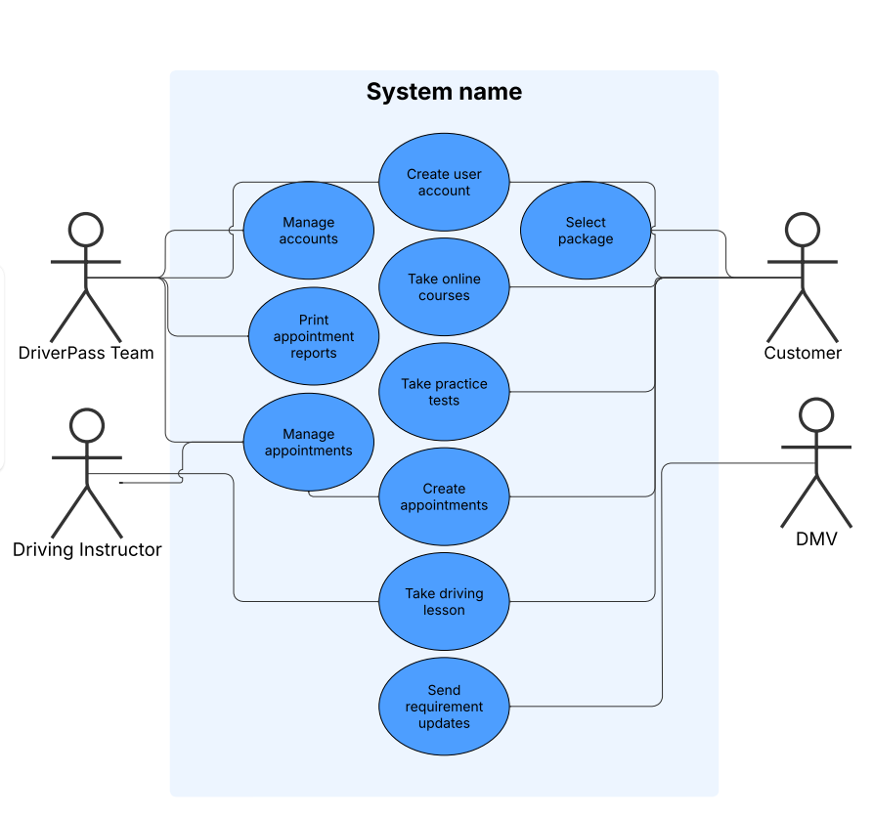

### UML Activity Diagrams

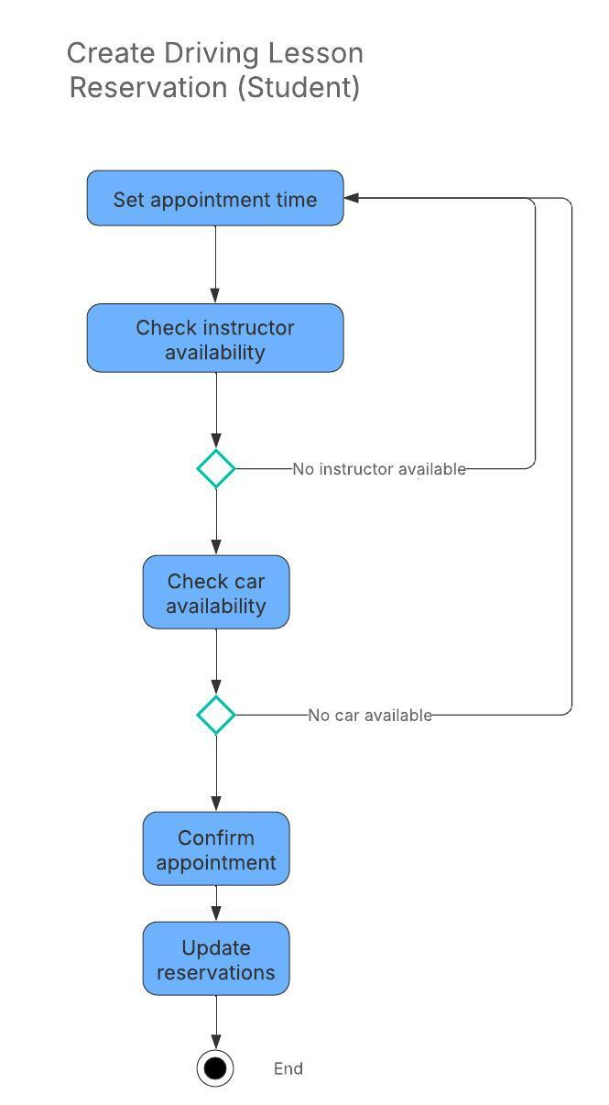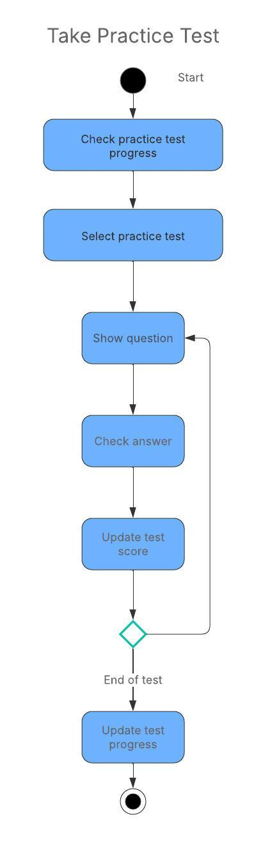

### UML Sequence Diagram

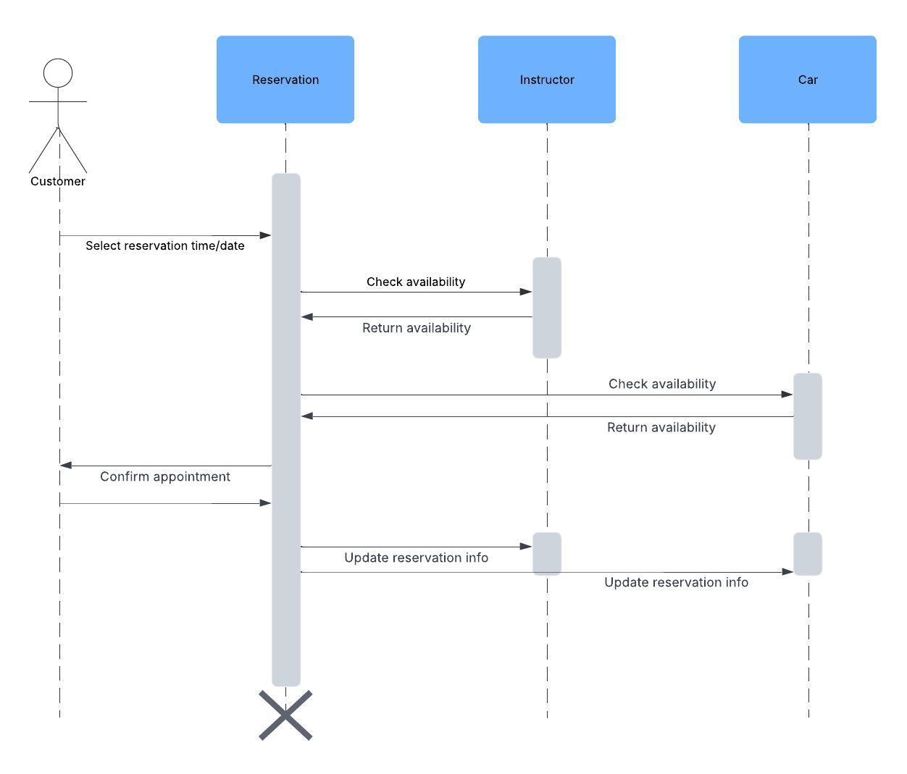

### UML Class Diagram

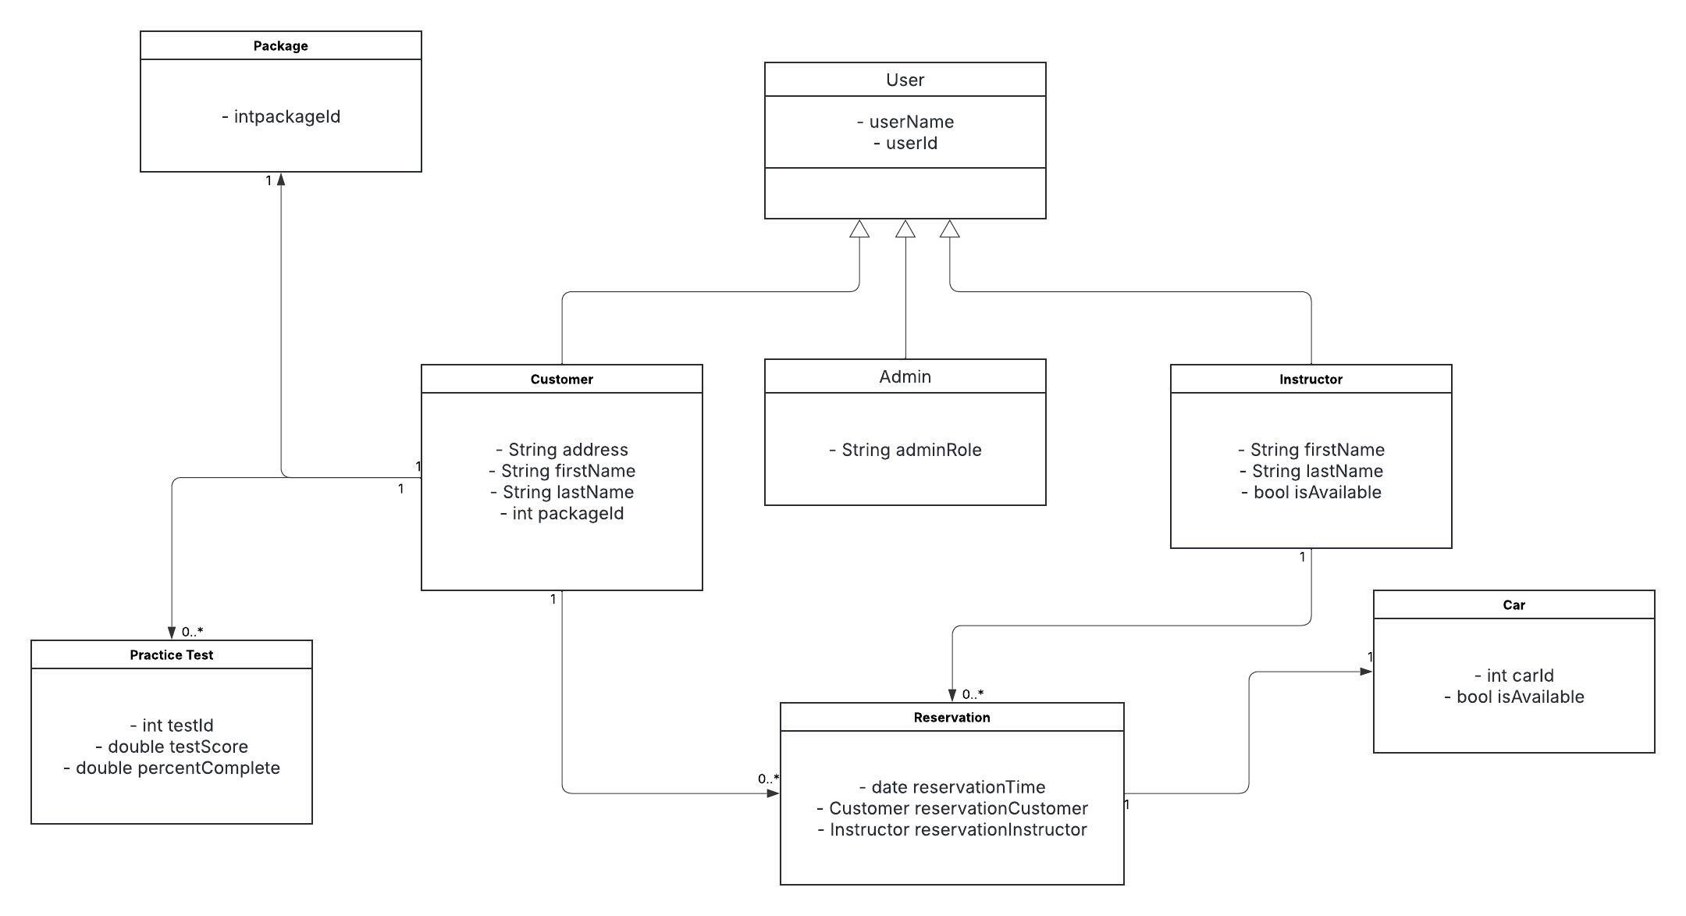

## Technical Requirements

The system will use a cloud-based deployment for server-side operations. The cloud server will handle user authentication, authorization, and security. It will also handle database functions including storing customer records, DMV requirements, and all other data needed on the backend. DriverPass will only pay for the features that are necessary and can scale up at any time. The IT team will need at least one computer capable of running the server management software (AWS, Azure, or others) to perform administrative actions and keep the system operational. A database management tool like MySQL or SQLite may also be necessary if not included with the server management software. Customers, administrators, and instructors can access the web application from any device with a web browser. Due to the cloud-based deployment, the hardware requirements are minimal, and because it is a web application, all front-end functionality is available on nearly all devices. This means that customers and instructors can perform any function from a smartphone or tablet if a PC is not available.